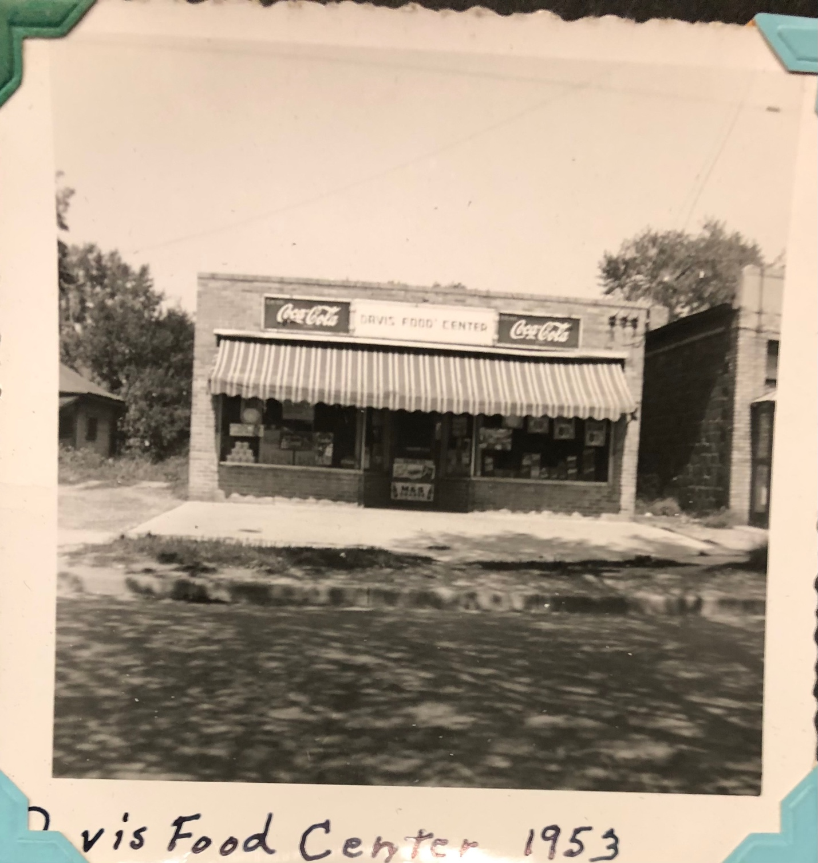

Davis Food Center 1953. Photograph. 1953. Davis Family Archives.

